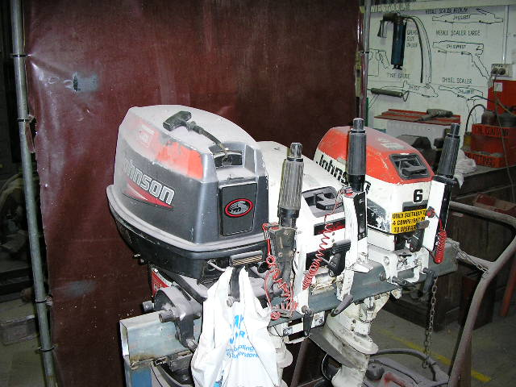 | Hazard Information Sheet
  Equipment: | Boat Motors
 | Equip Type: | Outboard Motors
 | Generic Description or  Specific Make / Model: | Outboard Motors
 | Type: | Petrol
 | Other Details

Operator Requirements: | Operators must be trained and competent to use this equipment safely.
Purpose For Which This Equip Is Designed: | Outboard motors for powering smaller water craft

Hazards & Risks:
Control Measures:
Entanglement:  Entanglement of operator in propeller causing cuts and severe laceration | Operator to be aware of inherent risk and ensure all limbs are free of propeller area before starting motor and to ensure motor turned off before placing hands or other limbs near motor
High Temperature or Fire:  Refuelling: When refuelling, sparks, flames, hot engine can ignite fuel. | Before refuelling, operator to shut down engine and turn off all electrical switches. When refuelling, ensure that there are no naked flames in the area. DO NOT SMOKE. Avoid spilling fuel and collect any fuel run off.
Noise:  Exposure to noise. | Personnel working with or in the vicinity of this equipment to wear suitable hearing protection.
Manual Handling:  Body strain if equip requires manual lifting. | Ask for assistance to lift or carry machine.

Disclaimer: In fulfilment of its statutory obligations, (ARS) & John Holland has taken what it considers to be all reasonable precautions and exercised due diligence to ensure that it has provided all relevant information on the safe use of the plant. However, except as required by law and only to the extent so required, (ARS) & John Holland does not make any representation, warranty or undertaking, express or implied, as to, or accept any responsibility or liability for, the accuracy or completeness of, or any errors in or omissions from, this Hazard Information Sheet. Except as required by law and only to the extent so required, neither (ARS) & John Holland nor any of its respective directors, officers, agents, or employees shall in any way be liable directly or indirectly to any person or body for any loss or damages, costs or expenses whatever arising out of or in connection with the information contained in this Hazard Information Sheet. | Date: 19/06/06
Equipment: | Outboard Motors  Petrol

Hazards & Risks: | Control Measures:
Suffocation:  Machine could be sited in a confined space and cause asphyxiation. | Operator instruction — site machine in well ventilated area.
Electrical:  Electric shock or burns due to damaged or poorly maintained electrical leads and cables. | User to regularly check no damage to cables to electrical appliances. Ensure cord(s) not positioned in or near water, nor likely to get damaged from falling objects, or pedestrian or other traffic.

Disclaimer: In fulfilment of its statutory obligations, (ARS) & John Holland has taken what it considers to be all reasonable precautions and exercised due diligence to ensure that it has provided all relevant information on the safe use of the plant. However, except as required by law and only to the extent so required, (ARS) & John Holland does not make any representation, warranty or undertaking, express or implied, as to, or accept any responsibility or liability for, the accuracy or completeness of, or any errors in or omissions from, this Hazard Information Sheet. Except as required by law and only to the extent so required, neither (ARS) & John Holland nor any of its respective directors, officers, agents, or employees shall in any way be liable directly or indirectly to any person or body for any loss or damages, costs or expenses whatever arising out of or in connection with the information contained in this Hazard Information Sheet. | Date: 19/06/06

